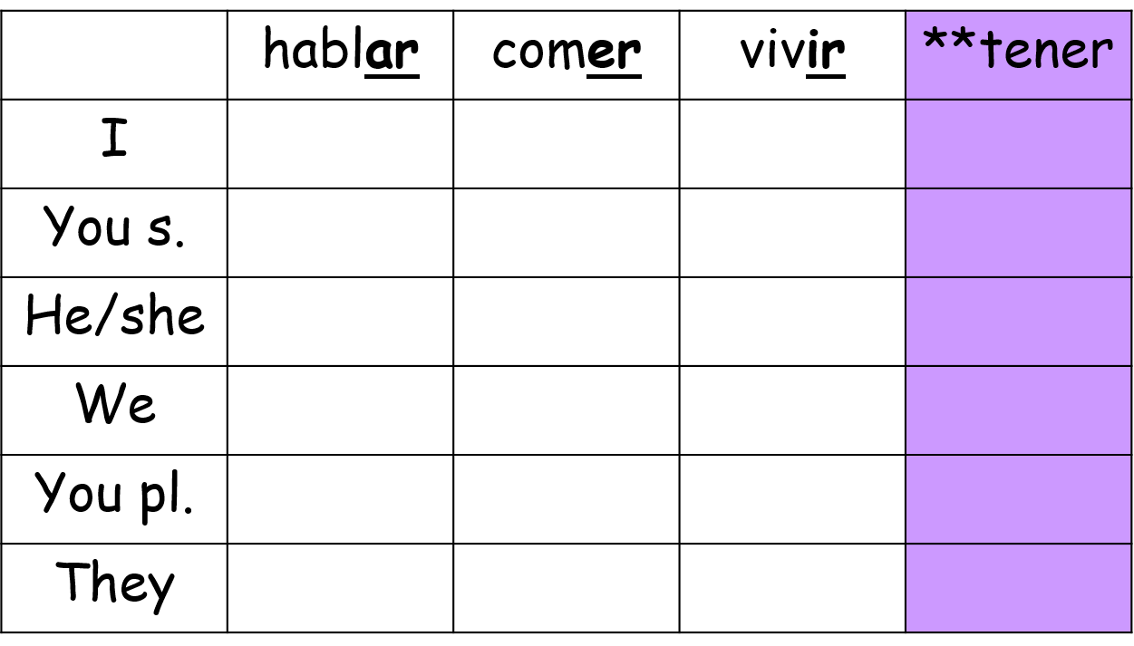

Extension Challenge: Can you translate the verbs above into English?

**5 Minute Challenge – El Presente**

Extension Challenge: Can you translate the verbs above into English?

**5 Minute Challenge – El Presente**