Me llamo:_____________________________________ 5-A-DAY SPANISH HOMEWORK
You will have a vocabulary test on the following words on Friday 10th November.
Homework: Complete the following exercises (1 a day over the next week). Remember 10/10 in your test = house point.

- el banco – the bank
- el restaurante – the restaurant
- el puerto – the port
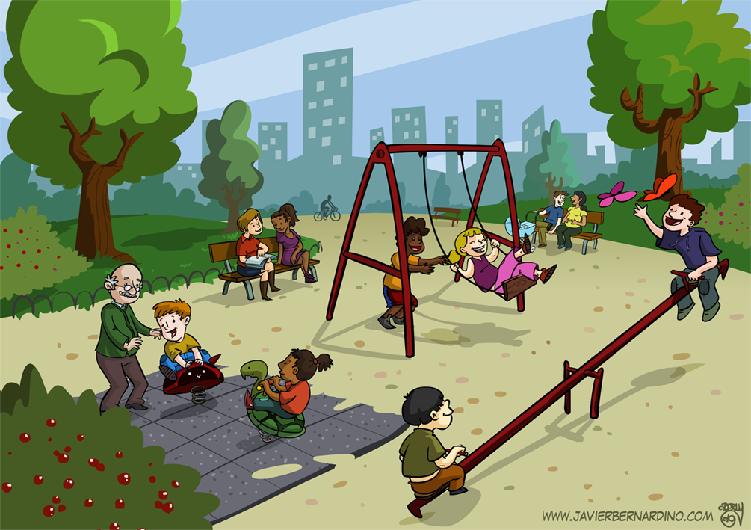
- el aeropuerto – the airport
- el mercado – the market
- el supermercado – the supermarket
- el parque – the park
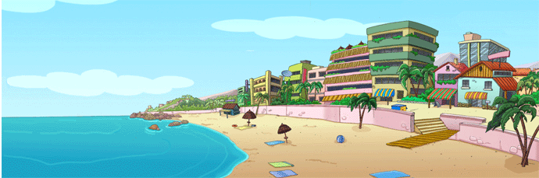
- la playa – the beach
- la tienda – the shop
- la piscina – the pool
Thursday 2nd November  Fill in the gaps  - el b_nc_  - _l r_st_ _r_nt_  - _ _ p_ _rt_  - e_ ae_o_uer_ _  - el m_rc_d_  - e_ s_p_rm_rc_ _ _  - _l p_rq_ _  - la pl_y_  - l_ t_ _n_ _  - _ _ p_sc_n_ | Friday 3rd November  Fill in the gaps  - _l b_ _c_  - e_ _e_ta_r_ _t_  - _ _ _ue_ _o  - e_ a_ _rop_ _rt _  - _ _ _ _rca_ _  - _ _ _ _p_r_ _rc_ _ _  - _ _ p_ _q_ _  - l_ p_ _y_  - _ _ t_ _ _ _ a  - _ _ p_ _c_n_ | Saturday 4th November  Fill in the gaps  - _ _ ban_ _  - _ _ resta_ _ _ _ _ _  - _ _ pu_ _ _ _  - _ _ aerop_ _ _ _ _  - _ _ merc_ _ _  - _ _ superme_ _ _ _ _  - _ _ par_ _ _  - l _ pla_ _  - _ _ tie_ _ _  - _ _ pisc_ _ _ | Sunday 5th November  Fill in the gaps  - _ _ ba_ _ _  - _ _ res_ _ _ _ _ _ _ _  - _ _ pu_ _ _ _  - _ _ aer_ _ _ _ _ _ _  - _ _ me_ _ _ _ _  - _ _ superm _ _ _ _ _ _  - _ _ pa_ _ _ _  - l _ pl_ _ _  - _ _ ti_ _ _ _  - _ _ pi_ _ _ _ _

Monday 6th November  Fill in the gaps  - el b_ _ _ _  - _l r_ _ _ _ _ _ _ _ _ _  - _ _ p_ _ _ _ _  - e_ ae_ _ _ _ _ _ _ _  - _ _ m_ _ _ _ _ _  - _ _ su_ _rm_ _ _ _ _ _  - _ _ p_ _ _ _ _  - la pl_ _ _  - l_ t_ _ _ _ _  - _ _ pi_ _ _ _ _  Now write the Spanish for each of the following from memory ! Remember to check your answers afterwards.  - the bank -  - the restaurant -  - the port -  - the airport -  - the market -  - the supermarket -  - the park -  - the beach -  - the shop -  - the pool –  /10 | Tuesday 7th November  Fill in the gaps  - __ ban__  - __ rest________  - __ pu______  - __ aer___________  - __ me________  - __ sup____________  - __ par________  - __ pl_______  - __ ti_______  - __ pisc_____  Now write the Spanish for each of the following from memory ! Remember to check your answers afterwards.  - the bank -  - the restaurant -  - the port -  - the airport -  - the market -  - the supermarket -  - the park -  - the beach -  - the shop –  - the pool –  /10 | Wednesday 8th November  Fill in the gaps  - __ ba___  - __ res_________  - __ pu______  - __ ae____________  - __ me________  - __ sup____________  - __ p_______  - __ p________  - __ t________  - __ pi________  Now write the Spanish for each of the following from memory ! Remember to check your answers afterwards.  - the bank -  - the restaurant -  - the port -  - the airport -  - the market -  - the supermarket -  - the park -  - the beach -  - the shop –  - the pool –  /10 | Thursday 9th November  Fill in the gaps  - _l ba___ o  - _l res________e  - e_ pu_____o  - e_ ae_________to  - e_ me_____do  - e_ sup_________ado  - e_ p_____ue  - l_ p___ya  - _a t______da  - _a pi_____na  Now write the Spanish for each of the following from memory ! Remember to check your answers afterwards.  - the bank -  - the restaurant -  - the port -  - the airport -  - the market -  - the supermarket -  - the park -  - the beach -  - the shop –  - the pool –  /10
Still struggling? Log on to your Memrise account and complete the ‘Places in Town – Vocabulary Test’ course

