[](http://www.google.co.uk/url?sa=i&rct=j&q=&esrc=s&source=images&cd=&cad=rja&uact=8&ved=0ahUKEwjHhp6VwqjQAhXDchQKHWlCBJQQjRwIBw&url=http://xprides.com/2012-xp-silver-medal-horse-and-rider-teams/&bvm=bv.138493631,d.ZGg&psig=AFQjCNFI_aVfSZwHGRMD1OBAVaBOpGJ3xQ&ust=1479222168489418)[](http://www.google.co.uk/url?sa=i&rct=j&q=&esrc=s&source=images&cd=&cad=rja&uact=8&ved=0ahUKEwjMl87vwajQAhWDVBQKHTIbDooQjRwIBw&url=http://dir.indiamart.com/impcat/gold-medal.html&bvm=bv.138493631,d.ZGg&psig=AFQjCNEEokqe4pTJNUNfTzSFCL1mHEhFKQ&ust=1479222093460251)[](http://www.google.co.uk/url?sa=i&rct=j&q=&esrc=s&source=images&cd=&cad=rja&uact=8&ved=0ahUKEwjZurX8wajQAhWEOBQKHequCYkQjRwIBw&url=http://photo.elsoar.com/olympic-medals-gold-silver-bronze.html&psig=AFQjCNEFxIxxABCPrspEmUOgfUe0S4lIjg&ust=1479222123779820)[](http://www.google.co.uk/url?sa=i&rct=j&q=&esrc=s&source=images&cd=&cad=rja&uact=8&ved=0ahUKEwjZurX8wajQAhWEOBQKHequCYkQjRwIBw&url=http://photo.elsoar.com/olympic-medals-gold-silver-bronze.html&psig=AFQjCNEFxIxxABCPrspEmUOgfUe0S4lIjg&ust=1479222123779820)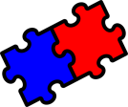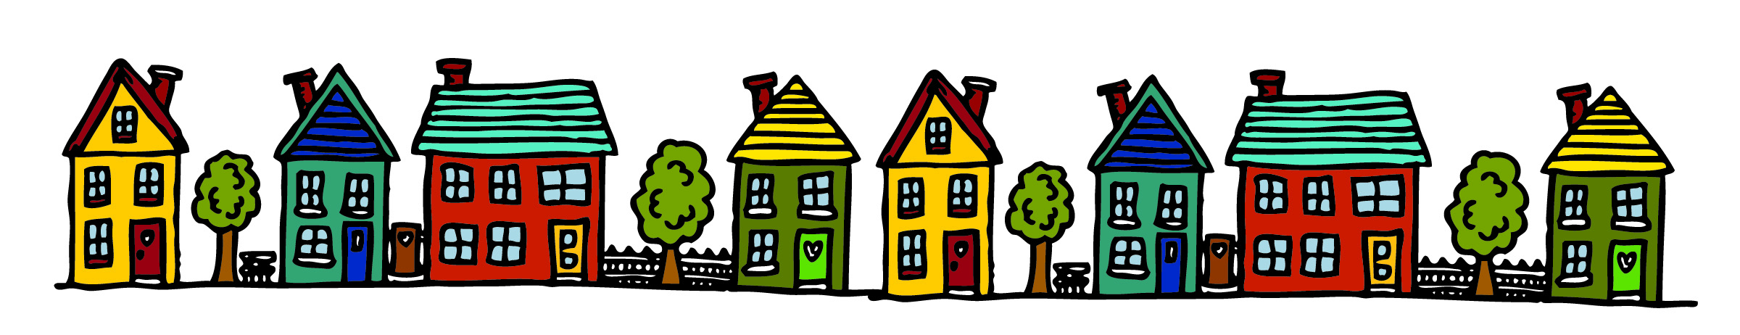

**¿Te gusta tu casa?**

**OPINIONS / LAS OPINIONES**

Me encanta – I love

Me gusta – I like

No me gusta – I don’t like

Odio – I hate

Detesto – I hate

Pienso que – I think that

**DEVELOPING YOUR OPINIONS**

sin embargo - however

aunque - although

porque es

– because it is

bastante – quite

muy – very

un poco – a bit

**GIVING OTHER PEOPLE’S OPINIONS**

A mi madre le gusta – My mum likes (it)

A mi padre le encanta – My dad loves (it)

**ADJECTIVES / ADJETIVOS**

grande – big

pequeño/a - small

moderno/a – modern

antiguo/a – old

nuevo/a – new

bonito/a – pretty

acogedor/a – cosy

cómodo/a – comfortable

aburrido/a - boring

**TYPES OF HOUSE / TIPOS DE CASA**

mi casa - my house

mi piso – my flat

mi granja – my farm