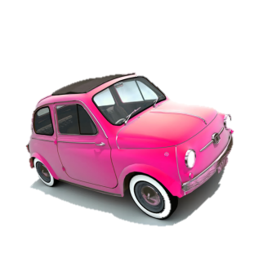Me llamo _______________

Mis Vacaciones – My Holidays

**Answers**

**In green pen**

1. **Tick each correct word on your worksheet**
2. **Correct each incorrect word**
3. **Glue your worksheet into your book neatly**
4. Normally I go London with my family because it’s interesting. I prefer to travel by train because it’s cheap.

|  |  |  |  |
| --- | --- | --- | --- |
| Normalmente | voy | a | Londres |
| con | mi | familia | porque |
| es | interesante | Prefiero | viajar |
| en | tren | porque | es |
| barato |

1. Sometimes I go to Scotland with my parents because it’s fun. I prefer to travel by car because it’s clean.

|  |  |  |  |
| --- | --- | --- | --- |
| A | veces | voy | a |
| Escocia | con | mis | padres |
| porque | es | divertido | Prefiero |
| viajar | en | coche | porque |
| es | limpio |

1. I always (*Always I go to*) go to France with my mum because it’s fascinating. I prefer to travel by ferry because it’s fun.

|  |  |  |  |
| --- | --- | --- | --- |
| Siempre | voy | a | Francia |
| con | mi | madre | porque |
| es | fascinante | Prefiero | viajar |
| en | ferry | porque | es |
| C:\Users\Danni\AppData\Local\Microsoft\Windows\Temporary Internet Files\Content.IE5\GN3R2XBJ\MC900089376[1].wmfdivertido |

**ANSWERS**

1. Each year I go to Spain with my grandparents because it’s interesting. I prefer to travel by plane because it’s quicker (*more quick).*

|  |  |  |  |  |
| --- | --- | --- | --- | --- |
| Cada | año | voy | a | |
| España | con | mis | abuelos | |
| porque | es | interesante | Prefiero | |
| viajar | en | avión | porque | |
| es | más | rápido. | |

1. Often I go to Italy with my friends because it’s fascinating. I prefer to travel by plane because it’s fun.

|  |  |  |  |
| --- | --- | --- | --- |
| A | menudo | voy | a |
| Italia | con | mis | amigos |
| porque | es | fascinante | Prefiero |
| viajar | en | avión | porque |
| es | divertido |