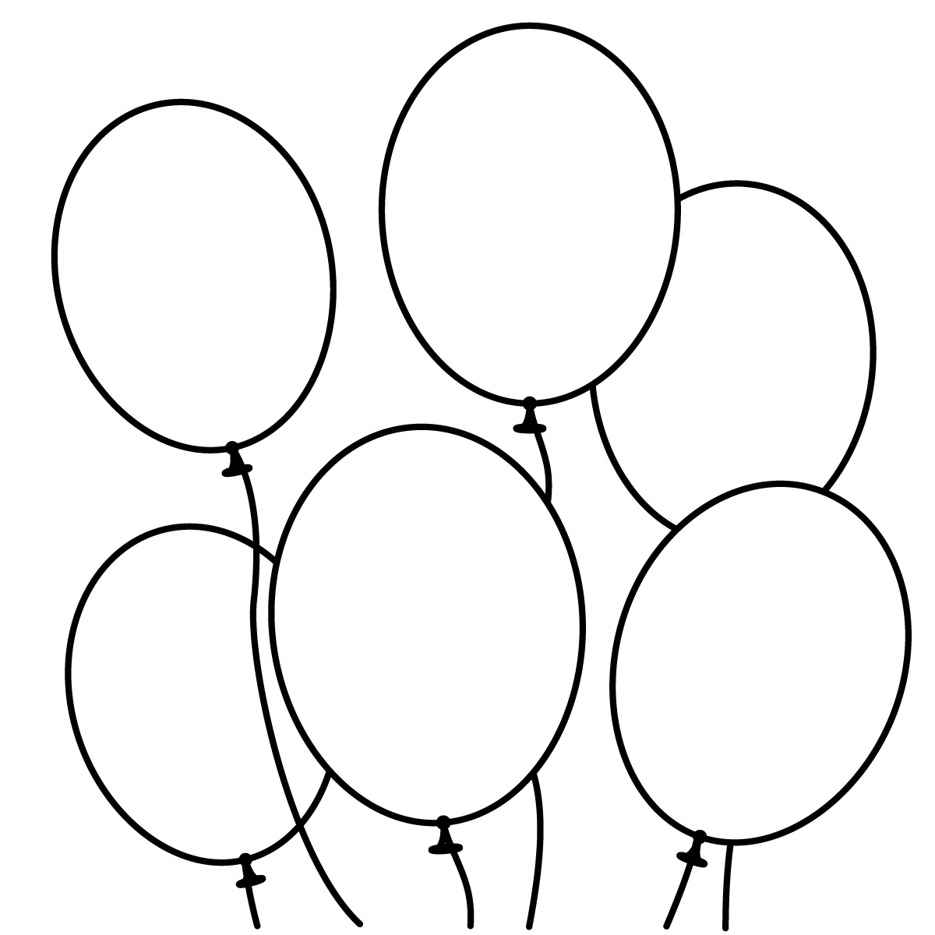[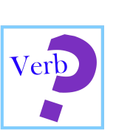](https://www.google.co.uk/url?sa=i&rct=j&q=&esrc=s&source=images&cd=&cad=rja&uact=8&ved=0ahUKEwi08NLY0p3NAhXkDsAKHQ0zB_cQjRwIBw&url=https://www.tes.com/lessons/cL74ZQIJYP5a6w/verbs&psig=AFQjCNHnAlDeyGoxuINl1fDGORfbZrfpwA&ust=1465654512215022)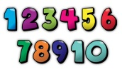

**ACTIVITY 4:**

**Los Verbos**

**Match up the infinitives below**

|  |  |
| --- | --- |
| 1. **ir =h** | 1. to live |
| 1. tener | 1. to eat |
| 1. ser | 1. to hate |
| 1. hacer | 1. to have |
| 1. gustar | 1. to call |
| 1. jugar | 1. to need |
| 1. beber | 1. to be able to |
| 1. querer | 1. to go |
| 1. poder | 1. to want |
| 1. vivir | 1. to be |
| 1. comer | 1. to drink |
| 1. necesitar | 1. to play |
| 1. llamar | 1. to do |
| 1. odiar | 1. to like |

**Score = /14**

**ACTIVITY 3:**

**Vocabulario general**

**How many can you translate into English?**

¿cómo te llamas? –

me llamo -

gracias –

de nada -

por favor –

hasta luego –

adiós –

sí -

soy de –

tengo doce años –

vivo en –

con –

en -

a -

**Score = /14**

**ACTIVITY 1:**

**Los Números**

**Unscramble the letters to spell a number in Spanish.**

e.g. acanertu = cuarenta (40)

tneainccu = _________________

retce = ____________________

hntocaea = _________________

nvetaon = __________________

traocu = ___________________

tsenate = __________________

noce = ____________________

nievte = ___________________

tntarie = __________________

inonuevti = _________________

tracoerc = _________________

neci = ____________________

**Score = /12**

**ACTIVITY 2:**

**Los Números y los colores**

**Colour in each of the balloons with the correct colour!**

dieciocho = rojo

cincuenta y seis = rosa

ochenta y nueve = amarillo

noventa y cuatro = verde

setenta y siete = azul

cuarenta y dos = naranja

**Score = /12**

42

56

18

89

94

77